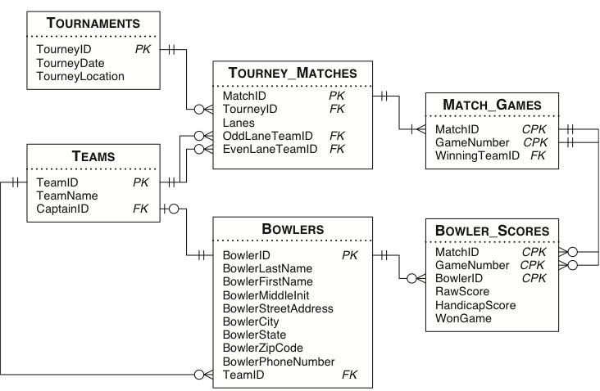

Show first name and last name of bowler, and indicate whether bowler scores ‘Strike’ in last round. A bowler scores ‘Strike’ in last round when his handicap score is greater than his raw score by 30 points.

